_____________________’s  WORD BANK |  | an  A a  ask  at  and  about  asked | back  B b  be  boy  big  by
can  C c  children  come  came  could | dad  D d  down  do  don’t  day | eat  E e  every | for  F f  fun  full  from  friend
go  G g  got  get  girl | had  H h  has  he  his  house  here help | I  I i  is  it  in  it’s  into | just  J j  jump
kick  K k  king | like  L l  look  love  little | mum  M m  me made  my make  Mr Mrs | no  N n  not  now
off  O o  on  our  out | pull  P p  put  people | queen  Q q | ran  R r  read  run
S s  sat  sit see  said so  some saw  says school | T t  to the  this then  them they  today there  time their | us  U u  up | very  V v
W w  will with  we went  when what  were where | X x | yes  Y y | zoo  Z z

Strategies for sight reading
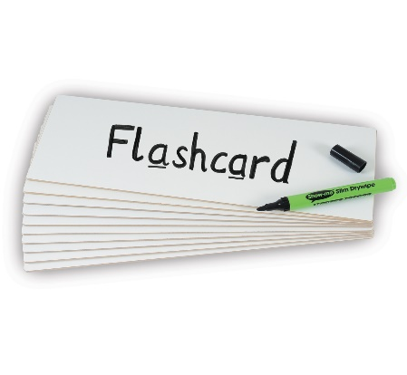  Quick Fire Flashcards  Writing key words on flashcards/pieces of paper and practising them daily can help child to quickly recall words. |   Reading  Reading is the most valuable tool. The more children read, the more familiar and comfortable they will become with a variety of words. | 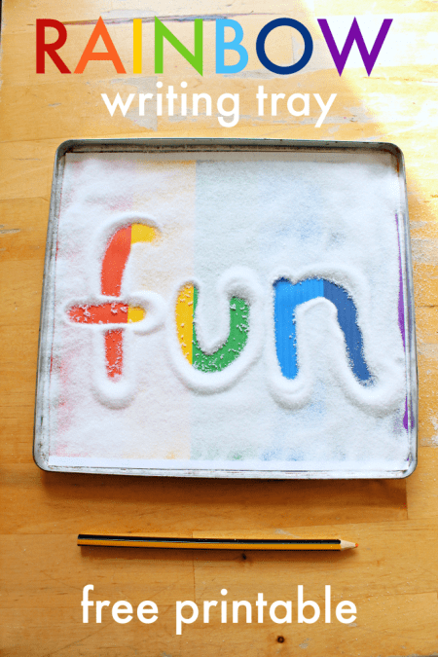  Sensory Literacy  Writing and copying words in foam, paint, glitter (e.c.t) before reading them, can make certain words appeal to children.
  Word Hunt  Hide key words around the house/garden and go on a word hunt. See if you can find any specific key words in your book. | 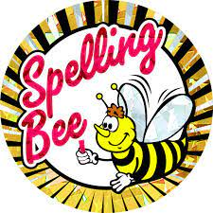  Spelling  As children learn how to spell familiar words, they become more confident in identifying the sound patterns within them. | 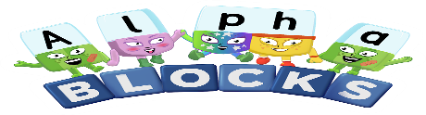  Videos  There a lots of fun and interactive songs, games and videos available online to help your child with their sight reading. These are available on Cbeebies, YouTube, Top Marks, ICT Games and BBC iPlayer.

