

**St Mary’s R.C. Primary School Admissions Policy for September 2025**

# Vision:

We believe that every child is a gift from God, therefore, we aim to provide an outstanding and happy Catholic education

which develops the ‘whole child’ whilst enabling them to reach their full potential.

**Mission statement:**

**We love God** … so we follow the examples of Jesus

**We love learning** … so we always do our very best in everything

**We love each other** … so we treat each other as we want to be treated

St Mary’s RC Primary School is a Catholic School in the trusteeship of the Diocese of Salford. It is maintained by Rochdale Metropolitan Borough Council and is a voluntary aided school. The Governing board is the admissions authority and is responsible for taking all decisions on applications for admissions. The co-ordination of admissions arrangements is undertaken by the Local Authority.

For the school’s year commencing September 2025, the governing board has determined that the number of children to be admitted to Reception will be 30.

The school’s role is to participate in the mission of the Catholic Church by providing a curriculum, including Catholic religious education and worship, which will help children to grow in their understanding of the Good News and in the practice of their faith. The school will help the children develop fully as human beings and prepare them to undertake their responsibilities as Catholics in society. The school requires all parents applying for a place here to understand and respect this ethos and its importance to the school community. This does not affect the rights of parents who are not of the Catholic faith to apply for a place here.

Admissions to the school will be determined by the governing board. Parents must complete a Local Authority Preference Form or apply online via the website <http://www.rochdale.gov.uk/schooladmissions>. Proof of baptism will be required for Roman catholic applicants. The school office will request a copy of the baptism certificate from all applications after the deadline.

If there are fewer than **30** applications, all applicants will be offered places. If there are more applications than the number of places available, the following oversubscription criteria will be applied:

**Admissions Criteria:**

1. Baptised Roman Catholic Looked After Children, Baptised Roman Catholic previously Looked After Children and Looked After Children adopted from overseas.
2. Baptised Roman Catholic children resident in the parishes of St Mary’s*
3. Other Baptised Catholic Children who have a sibling in the school at the time of admission
4. Other baptised Catholic children.
5. Looked After Children and previously Looked After Children.
6. Other children who have a sibling in the school at the time of admission.
7. All remaining applicants.

## *Parish boundaries

The parish boundaires are located from the Rochdale - Rossendale District boundary near Brownhouse Wham Reservoir, N along that boundary to Hades Hill and then along Rochdale - Calderdale District boundary, across Warland Reservoir, crossing Turvin Road (B6138) and Halifax Road (A58) to M62 Motorway near junction 22. Then W along the motorway to Lower Booth Hollins Farm and by a bee-line across Hollingworth Lake to Smithy Bridge Road past the Smithy Bridge Railway Station to New Road, Halifax Road, Union Road. Then W by a beeline to the junction of Thimble Close and Birch Road, N along Birch Road to its junction with Ramsden Road and W by a beeline to Rochdale – Rossendale District boundary.

Please see *Appendix 1* for a map of the parish boundaries or go to the following link to see more detail <https://boundaries.stjosephsmanchester.co.uk/?page=G&id=G013>

## Ranking

Where several children fall into the same criteria group as above, applications will be ranked based on the walking distance from home to school. Walking distances are calculated by the local authority on behalf of the governing board and are measured using the Rochdale GIS system which measures the walking

distance from the nearest point where the home address joins the Ordnance Survey Highways Network to the defined admissions gate at the school. Pupils who live closer to the school based on this calculation will receive higher priority for the place.

In instances where two or more applications cannot be separated using this oversubscription criteria, random allocation will be used to decide in which order the available place(s) shall be offered. In such cases, the random allocation will be supervised by someone independent of the school.

## Notes for Applicants:

1. All applications will be considered at the same time and after the closing date for admissions, which is 15th January 2025. Applications received after this date will be treated as a late application and will not be considered until after the main allocation of places has taken place.
2. A Looked After Child is a child who is (a) in the care of a Local Authority, or (b) being provided with accommodation by a Local Authority in the exercise of their Social Services functions (under section 22(1) of the Children Act 1989. A previously Looked After Child is one who immediately moved on from that status after becoming subject to an adoption, residence or special guardianship order. Included in this definition are those children who appear to the governing board to have been in state care outside of England and who ceased to be in state care as a result of being adopted.
3. For a child to be considered as a Catholic evidence of a Catholic Baptism or Certificate of Reception into the Catholic Church is required. Written evidence of reception into the Catholic Church can be obtained by referring to the Register of Receptions, or in some cases a sub-section of the Baptismal Registers of the Church in which the Rite of Reception took place. If, for example, a child has been baptised in the Church of England and the parents are subsequently admitted to the Catholic Church through the RCIA programme, the child must also be admitted to the Church by the Rite of Reception.

The governing board will require written evidence in the form of a Certificate of Reception before applications for school places can be considered for categories of ‘Baptised Catholics’. A Certificate of Reception is to include full name, date of birth, date of reception and parent(s) name(s). The certificate must also show that it is copied from the records kept by the place of reception.

Those who have difficulty obtaining written evidence of baptism for a good reason, may still be considered as baptised Catholics but only after they have been referred to the parish priest who, after consulting with the **Director of Education or officers of the DDFE** will decide how the question of baptism is to be resolved and how written evidence is to be produced in accordance with the law of the Church.

1. Home Address is considered to be the address where the child normally lives. Where care is split and a child moves between two addresses, the household in receipt of the child benefit would normally be the address used but the admission authority body reserves the right to request other evidence as fits the individual circumstance. Applicants should not state the address of another relative or person who has daily care of the child.
2. ‘Sibling’ is defined in these arrangements as full, half or stepbrothers and sisters, adopted and foster brothers and sisters who are living at the same address and are part of the same family unit. This does

not include cousins or other family relationships.

1. A waiting list for children who have not been offered a place will be kept by school and will be ranked according to the admission criteria. The waiting list does not consider the date the application was received or the length of time a child's name has been on the waiting list. This means that a child's position on the list may change if another applicant is refused a place and their child has higher priority in the admissions criteria. The waiting list will be kept until 31st December 2025.
2. For ‘In Year’ applications received outside the normal admissions round, if places are available they will be offered to those who apply. If there are places available but more applicants than places then the published oversubscription criteria will be applied.
3. If an application for admission has been turned down by the Governing Board, parents may appeal to an independent appeals panel. Parents must be allowed at least twenty school days from the date of notification that their application was unsuccessful to submit that appeal. Parents must give reasons for appealing in writing and the decision of the appeals panel is binding on the governors.
4. The governing board reserve the right to withdraw the offer of a school place where false evidence is received in relation to the application.
5. It is the duty of governors to comply with regulations on class size limits for children aged between rising five and seven. The governing board may exceed the regulations for twins and children from multiple births where one of the children is the 30th child admitted. This also applies to in-year applicants who are looked after/previously looked after children of UK service personnel or children who move into the area for whom there is no other school available within a reasonable distance.
6. All children are entitled to a full-time place in the September following their fourth birthday. Parents can defer the date their child is admitted to school until later in the school year, but not beyond the point at which they reach compulsory school age, or for children born between 1st April and 31st August, not beyond the beginning of the final term of the school year for which the offer is made. Where parents wish, children may attend part-time until later in the school year, but not beyond the point at which they reach compulsory school age.
7. Parents/Carers of a summer-born child (those born between 1st April and 31st August) may choose not to send their child to school until September following their fifth birthday and may request that they are admitted out of their normal age group (i.e. to Reception rather than Year 1).
8. Parents/Carers may request a place for their child outside of their normal age group, for example, if the child is gifted and talented or has experienced problems such as ill health. Where a request is made for placement outside of the child’s normal age group, school will take decisions on any such requests based on the circumstances of each case. This will include taking account of the parent’s views; information about the child’s academic, social and emotional development; where relevant, their medical history and the views of a medical professional; whether they have previously been educated outside their normal age group; and whether they may naturally have fallen into a lower age group if it were not for being born prematurely. If you wish to seek a place outside of the child’s normal age group, you should contact the

Headteacher in the first instance. We will arrange a meeting and any supporting documentation will be requested after this meeting before a decision is reached.

***n.***

### Complaints

To make a complaint if you are not happy with our application process you have until 17 May 2025. This must be made to the Office of the school Adjudicator (OSA) at the following web address: <https://www.gov.uk/government/publications/objection-to-school-admission-arrangements>

### Visits

We will hold two open sessions:

Tuesday 24th Sept @ 5-6pm

Thursday 7th Nov @ 4.30-5.30pm

Parents are encouraged to attend, look around the school and speak to EYFS staff, booking is not required

### Contact

St Mary’s Roman Catholic Primary School, Whitelees Road, Littleborough, OL15 8DU Tel: 01706 378032 Email: [office@smrc-lit.co.uk](mailto:office@smrc-lit.co.uk)

Policy approved July 2024 and is reviewed annually

Signed: Chair of Governors

## Appendix 1

***St Mary of the Annunciation*** DIOCESE OFU'SALFOR

....

=

WHITWORTH :;

* 1. . .

-....

*St Mary o f the Annunc,atton*

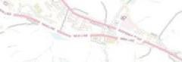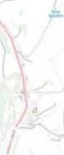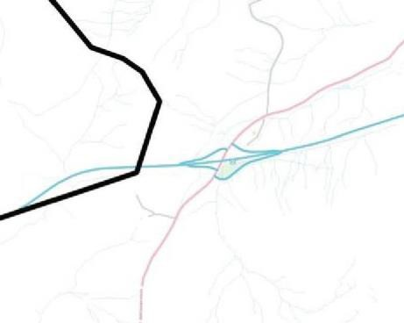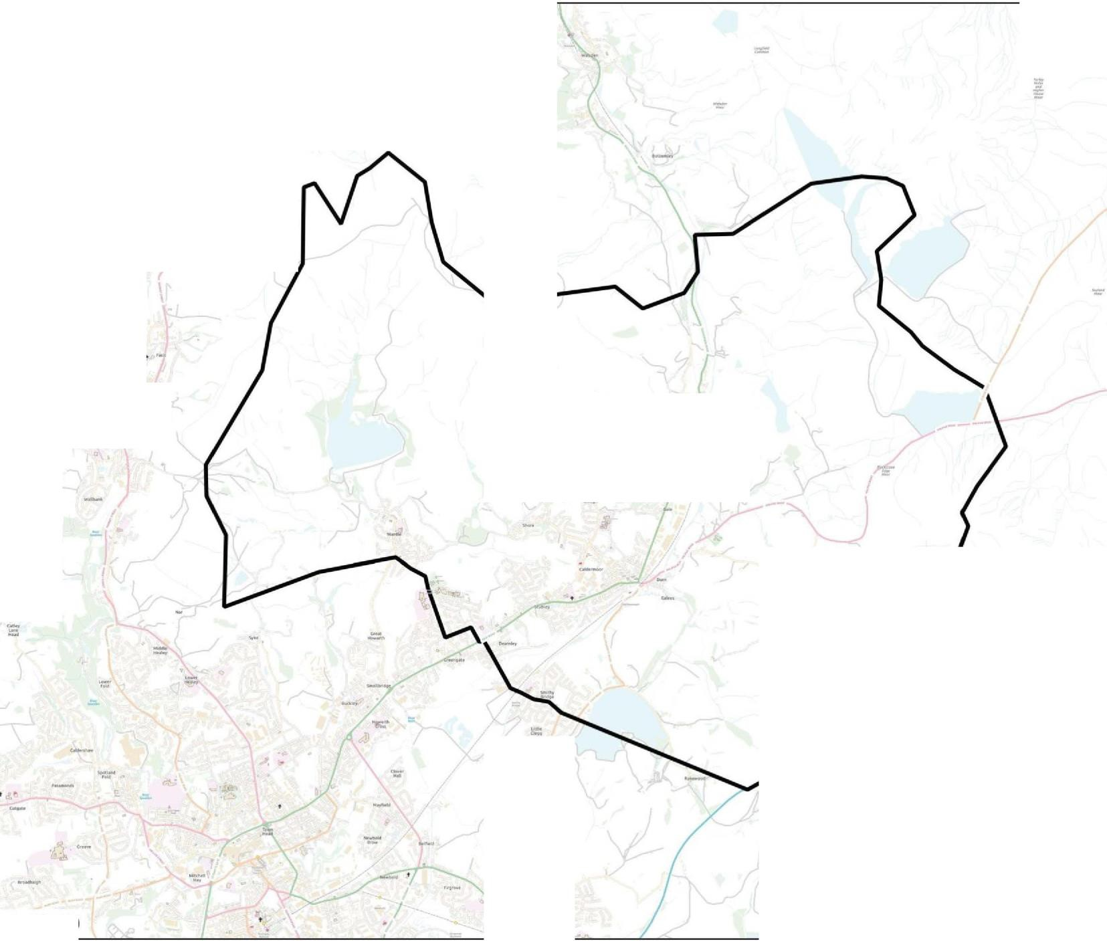

Scale 1 : 50 000 MI/-NROW *Contains OS data© Crown copyright and database right 2016*

Appendix 2

## Application for Placement of a Child Outside of their Normal Age Group

7